**KWAME NKRUMAH UNIVERSITY OF SCIENCE AND TECHNOLOGY**

COLLEGE OF ENGINEERING

CHEMICAL ENGINEERING DEPARTMENT

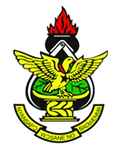

PRESENT THIS CERTIFICATE TO

…………..………………………………………………………………………..

For successful completion of the curriculum in

BSC CHEMICAL ENGINEEERING

On this 14th day of April, 2016.

…………………………………………… …………………………………………………

Dean, College of Engineering Chair, Chemical Engineering Department